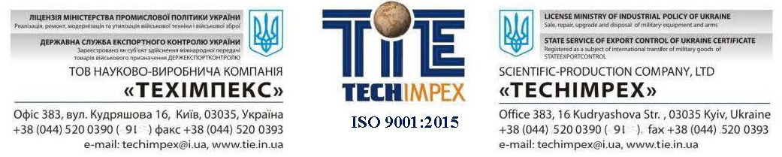

Mr.Deepak Gupta
President
D’GIPRO ENTERPRISES
deepak@dgipro.in

Dear Mr.Gupta

“TECHIMPEX” Ltd is a leading private defense company founded in 2003. The Company is a member of the State Defence Acquisition Program of Ukraine for the Ministry of Defence, Ministry of Interior, National Guards, State Border Control; it is registered with the State Service of Export Control. The Company employs more than 350 personnel and complies with ISO 9001:2015 quality management control standard.
Company sphere of activities
- manufacture, repair, upgrade, sales and disposal of the military equipment and military weapon;
- manufacture, repair of artillery and small arms;
- sales of non-military fire arms, ammunition, cold weapon and air guns;
Currently “TECHIMPEX” performs at own repair-manufacture facilities the following works:
- manufacture of APC VARAN8x8, tracked APC SWIMMER, 4x2 Light Tactical Vehicle; 7,62 mm KT-7.62 machine gun (analogue of PKM), 12,8 mm DShKM-T (analogue of DShKM); Weapon stations SPYS, UBM, GUARDA and BM-23-2;
- overhaul and upgrade of Т-54/55, Т-72, 122 mm self-propelled howitzer 2S1 Gvozdika, BMP-1, BMP-2, BMP-3, BTR-60, BTR-70, BTR-80, BRDM-2, BRDM-2RH, PZM-2, MT-LB, MT-LBu, MTO (mobile workshops), ZiL-135LM-T; BAZ-5937 “Osa”, ZSU-23-4 “Shilka”
- overhaul and upgrade of assembly units and aggregates for military equipment:
- engines type V-2, V-6, V-46-6, UTD-20, UTD-23, UTD-29, KamAZ, GaZ, YaMZ and others;
- axles, wheel hubs, final drives;
- transmissions;
- stabilization systems;
- sights and observation devices.

Truly Yours,

V.KALYNA
Director General

